**Personal Blog On IBM Cloud Static Web App**

**Problem Design And Innovation**

|  |  |
| --- | --- |
| **Date** | **26-10-2023** |
| **Team ID** | **678** |
| **Project Name** | **Personal Blog On IBM Cloud Static Web App** |

**1. Introduction**

A personal travel blog that takes you on a virtual journey around the globe, powered by the latest cloud-based static web app technology. Here, we blend the art of storytelling with the innovation of the cloud to bring you a dynamic travel experience. From sharing my own adventures to providing practical tips and detailed itineraries, "Roaming Clouds" is your digital companion for wanderlust. With the power of cloud static web apps, we ensure a seamless, lightning-fast browsing experience as we explore the wonders of the world together. So, fasten your virtual seatbelt, and let's embark on this digital adventure.

**2. Problem Statement:**

 Create a personal travel blog hosted on IBM Cloud Static Web Apps. Share your travel adventures, tips, and captivating photos with the world. Use IBM Cloud Static Web Apps to easily update your blog and document your journeys. Inspire others to explore the beauty of the world and forge unforgettable memories!

**REQUIREMENT GATHERING AND ANALYSIS :**

* Make understand the purpose of the website.
* Gather content of webpage regarding to personal travel blog.
* List the features and functionalities you want to include.
* Researching similar websites or competitors for inspiration.

**PLANNING :**

• Choose the technology stack

1. HTML

2. CSS

• Planning the website structure.

• Decide on a hosting provider.

• Gather the travel photos and videos you will need.

• Insert navigation bar in the web page for usage of user.

**DEVELOPMENT :**

1. Starting with basic structure using HTML.

2. Also using the CSS.

Source code:

HTML File

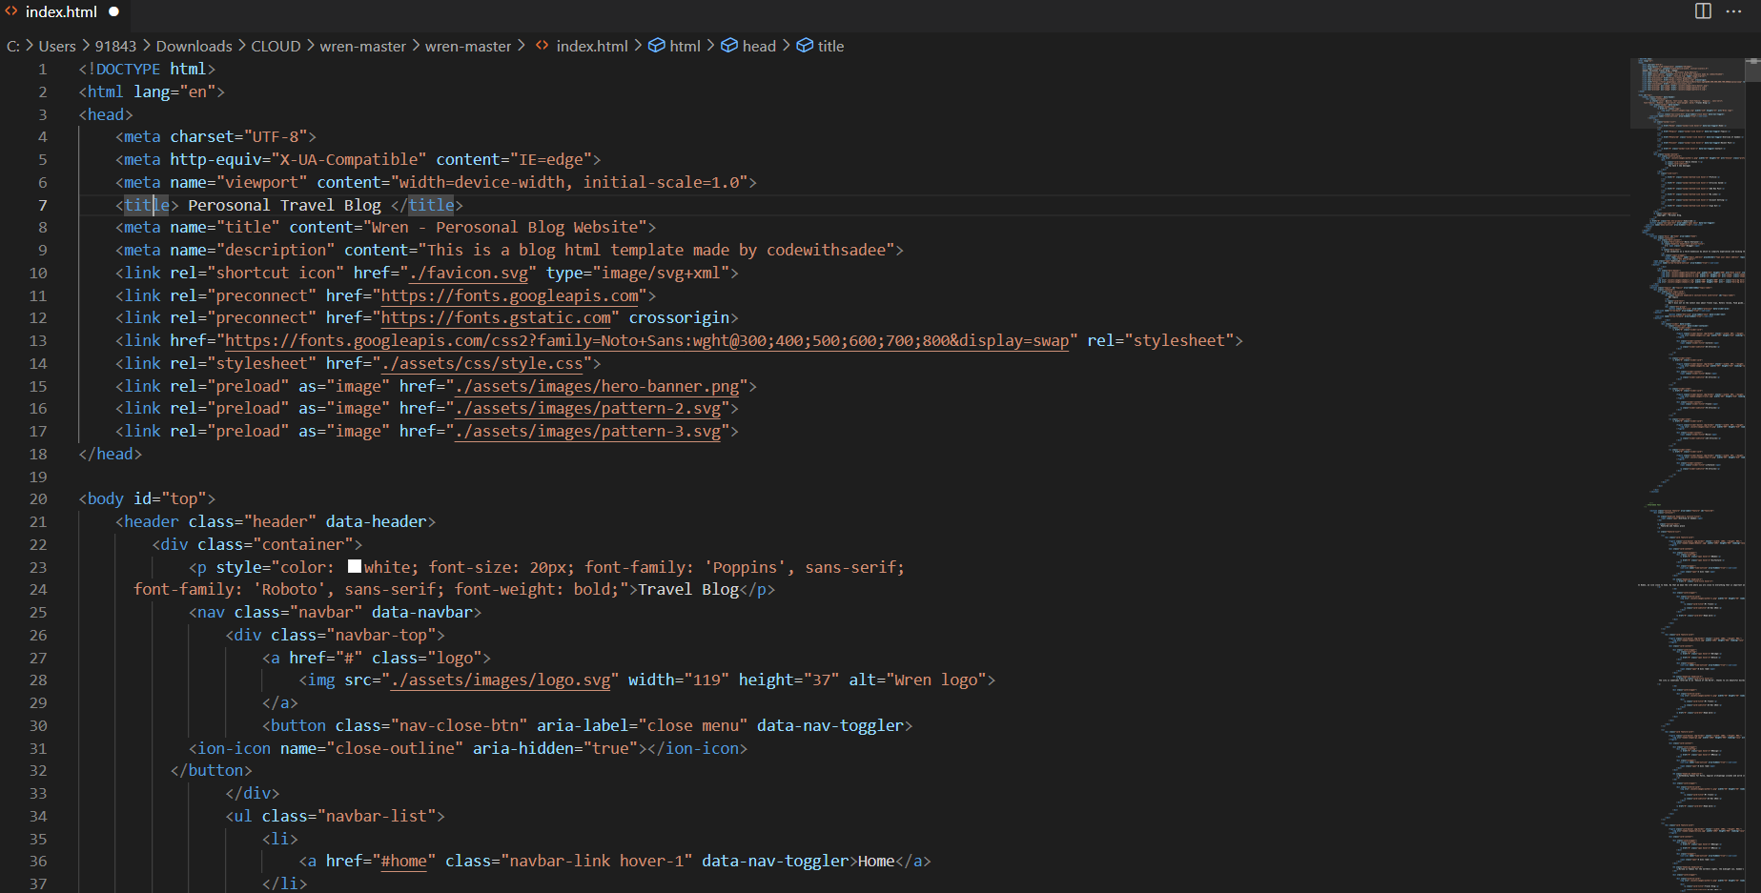 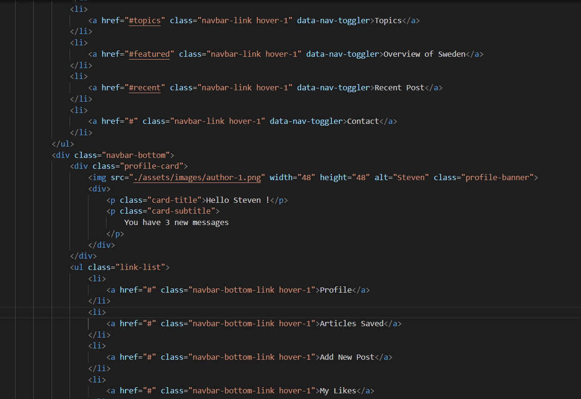 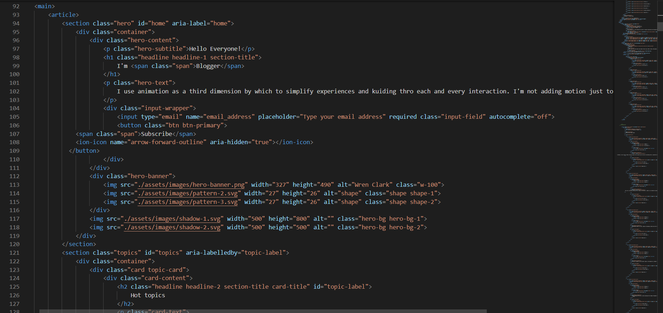 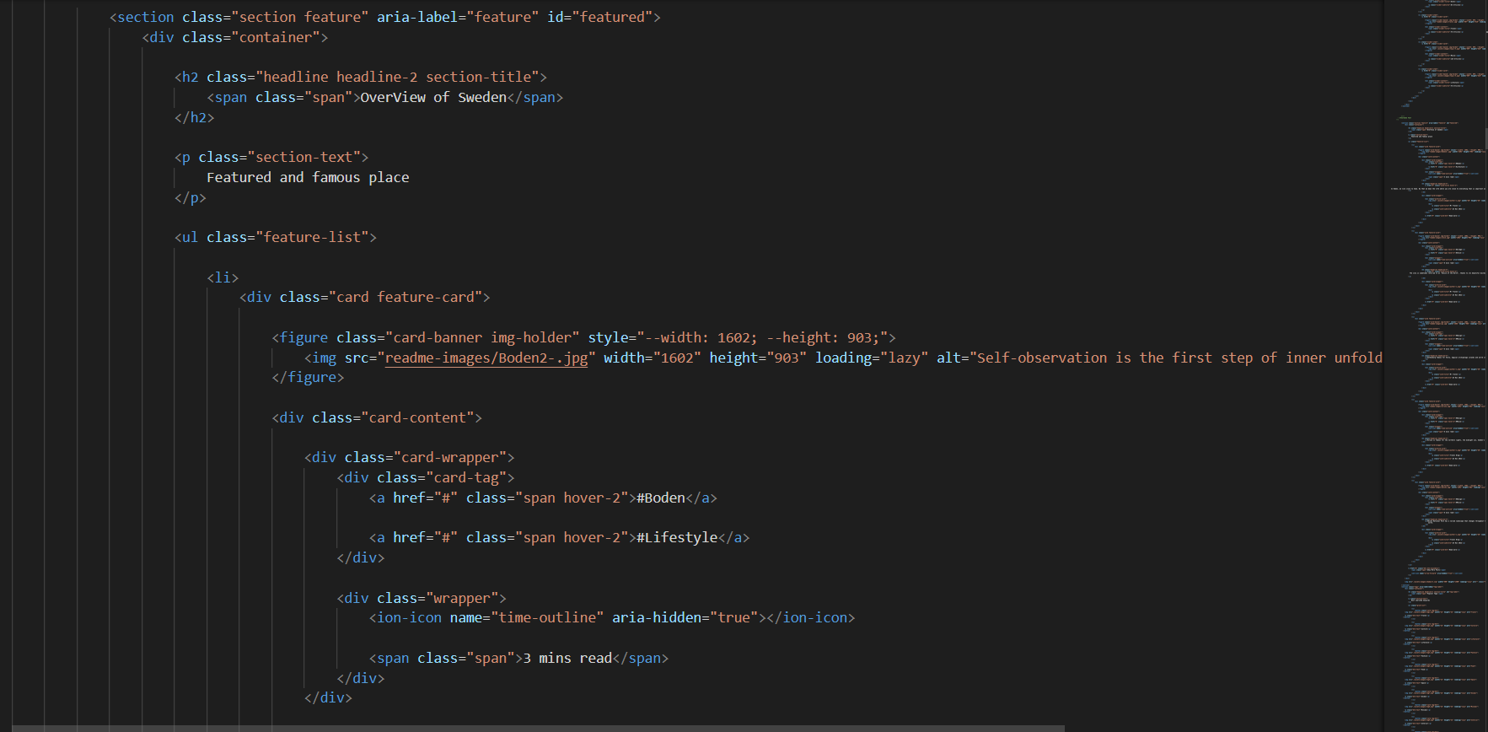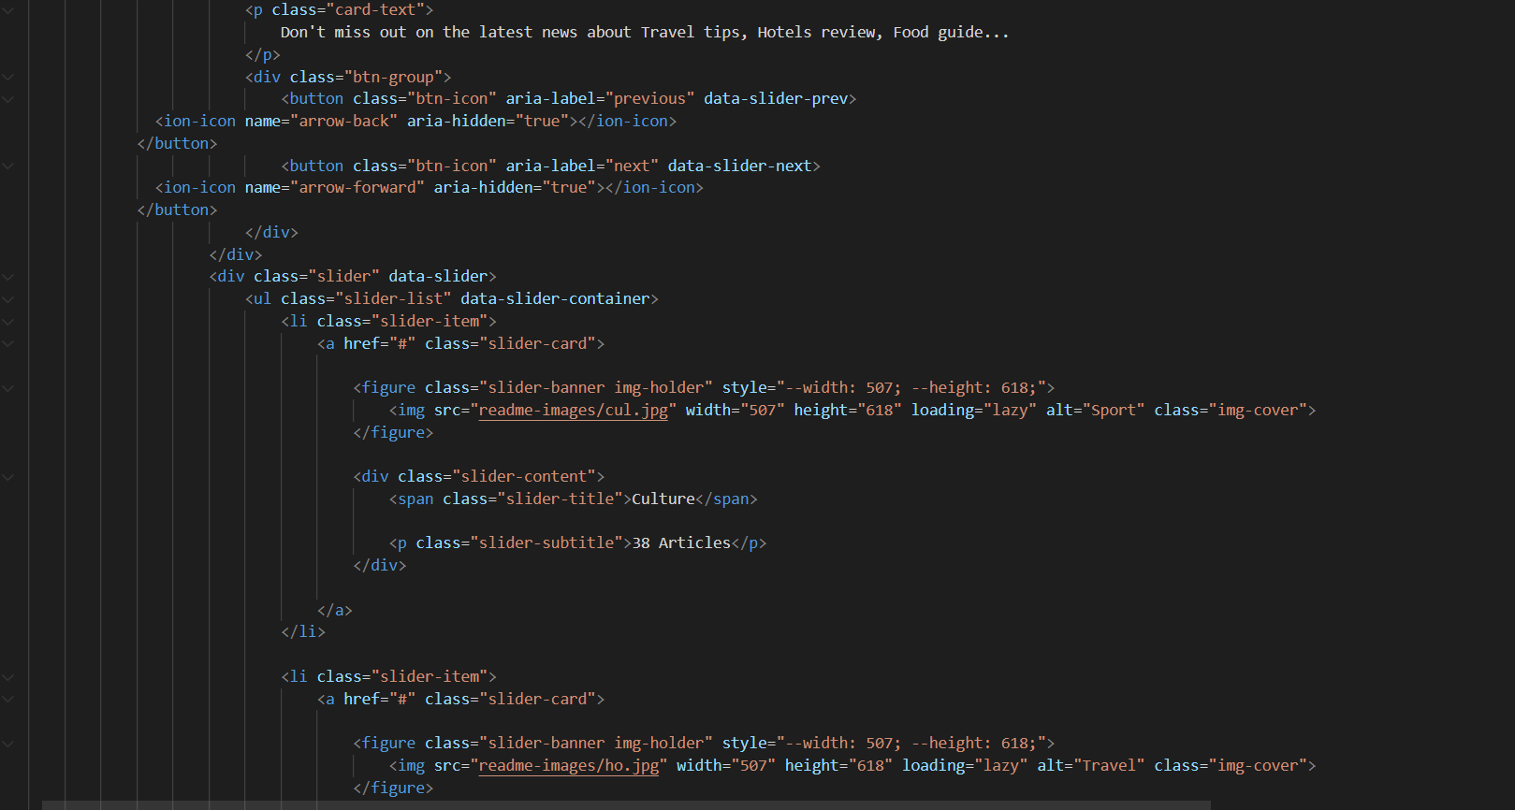

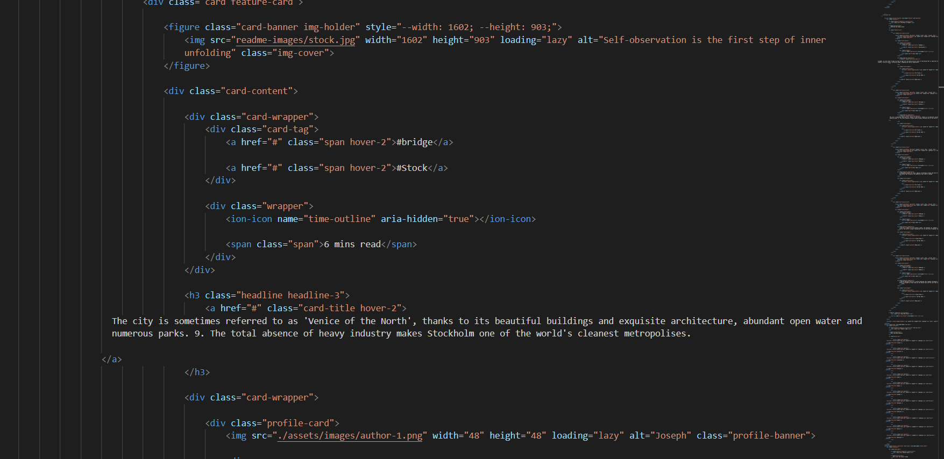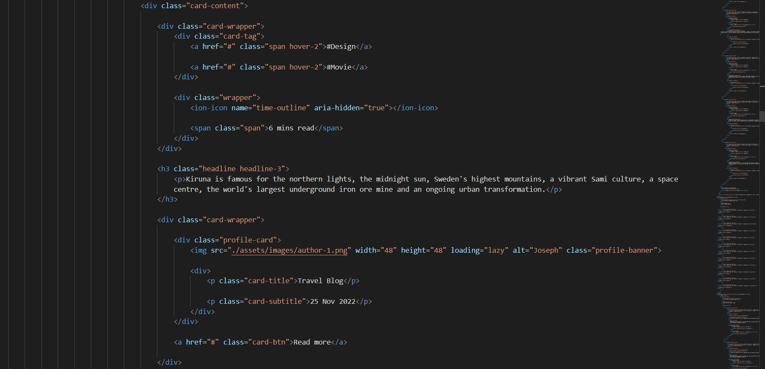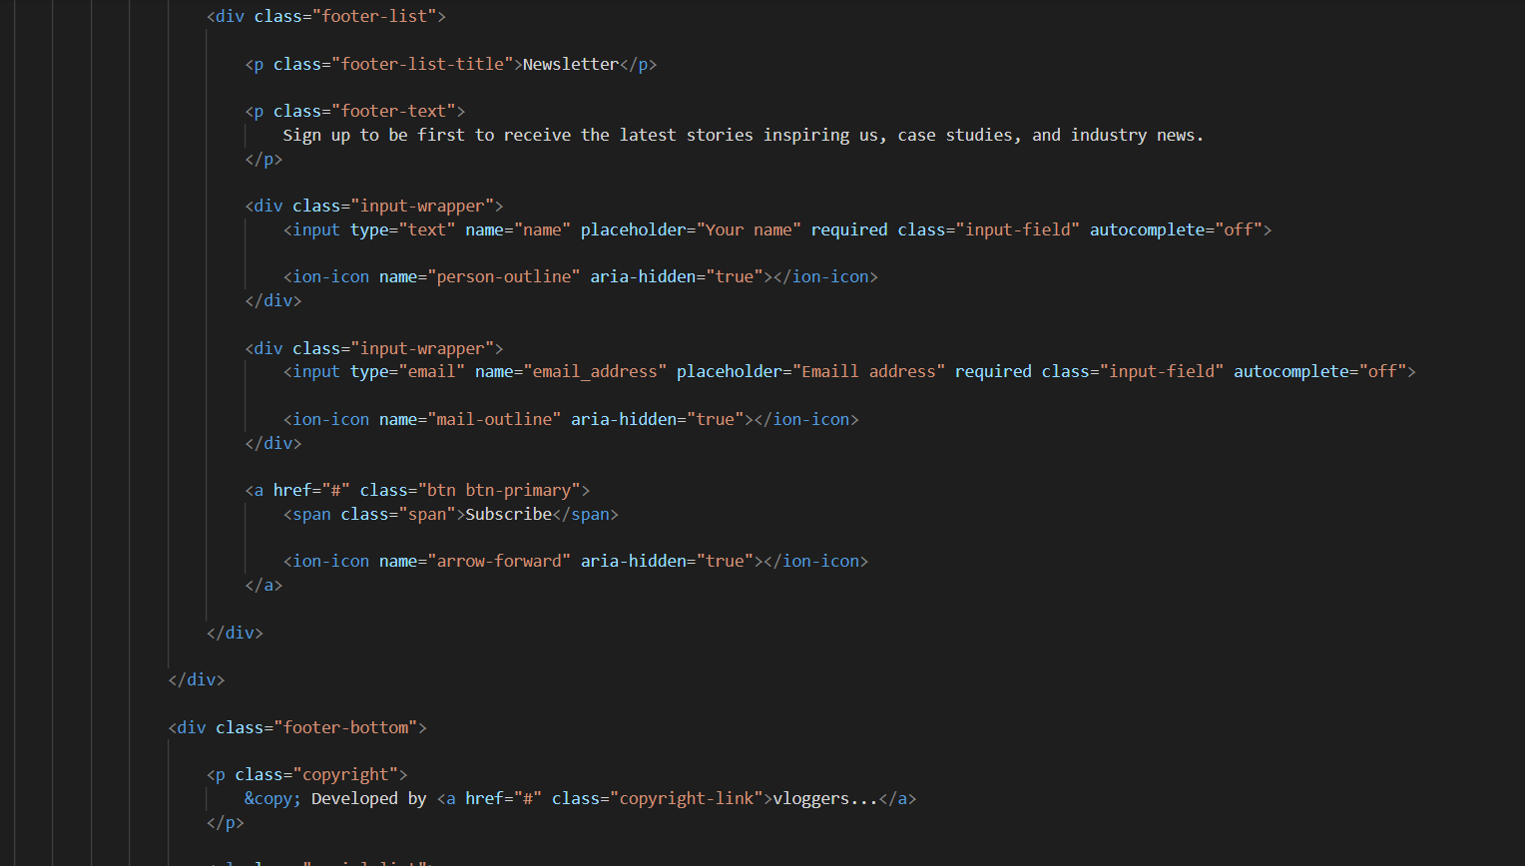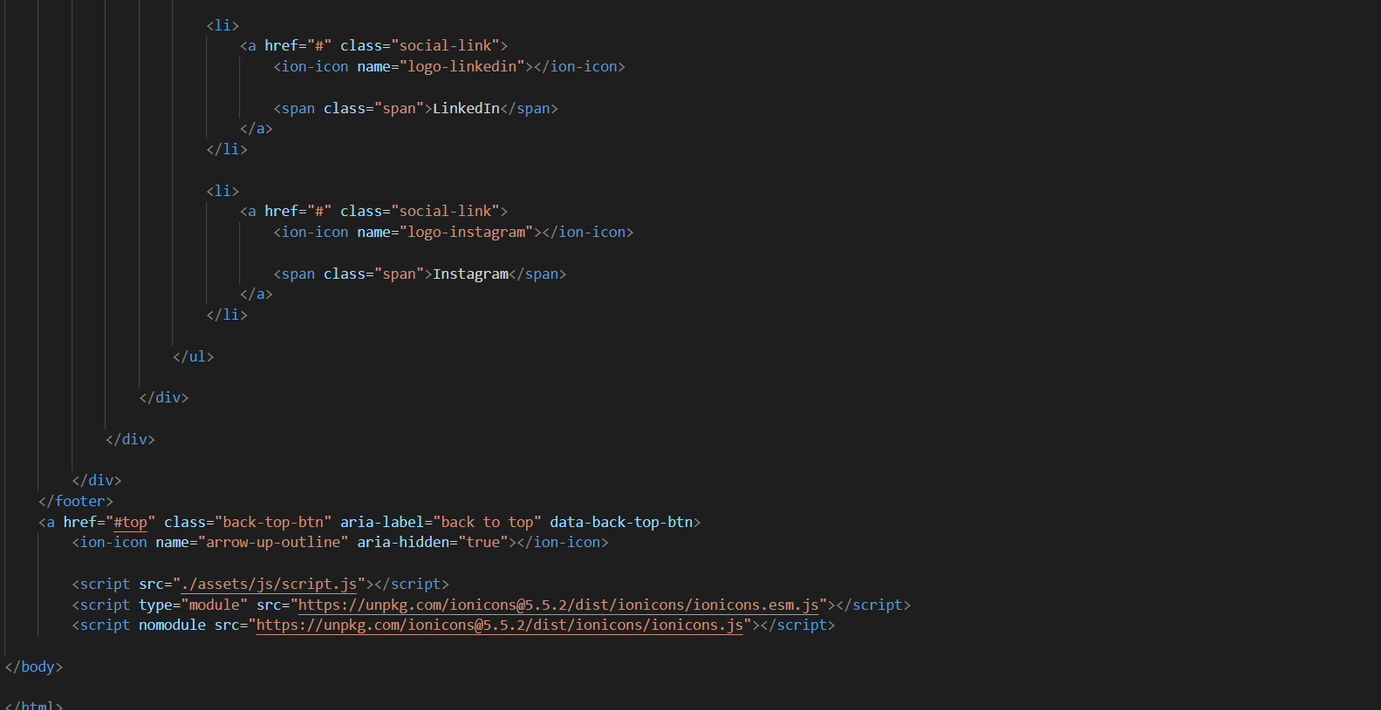

**CSS File**

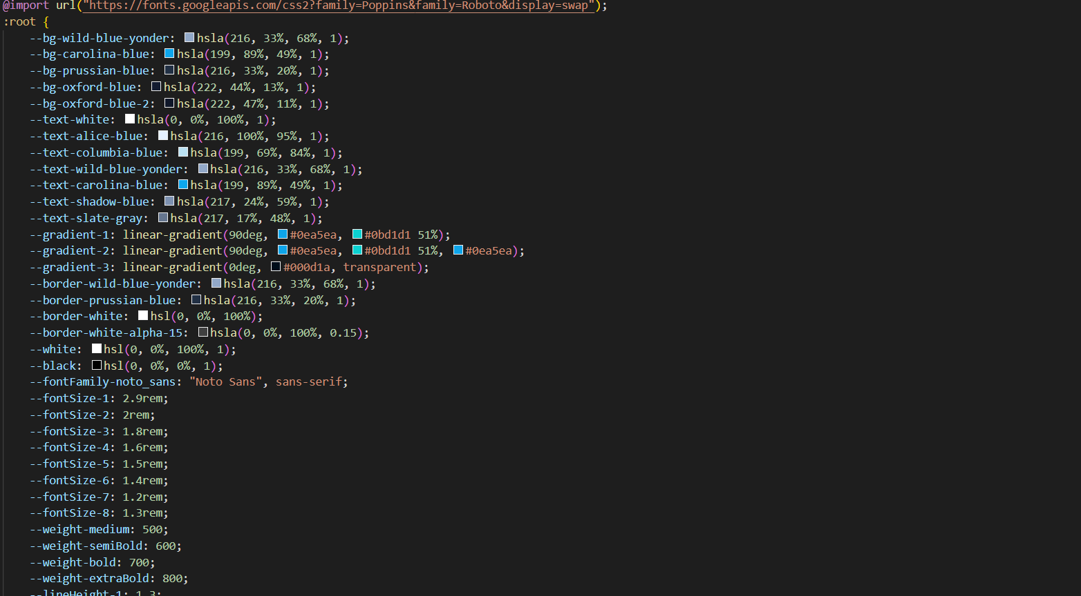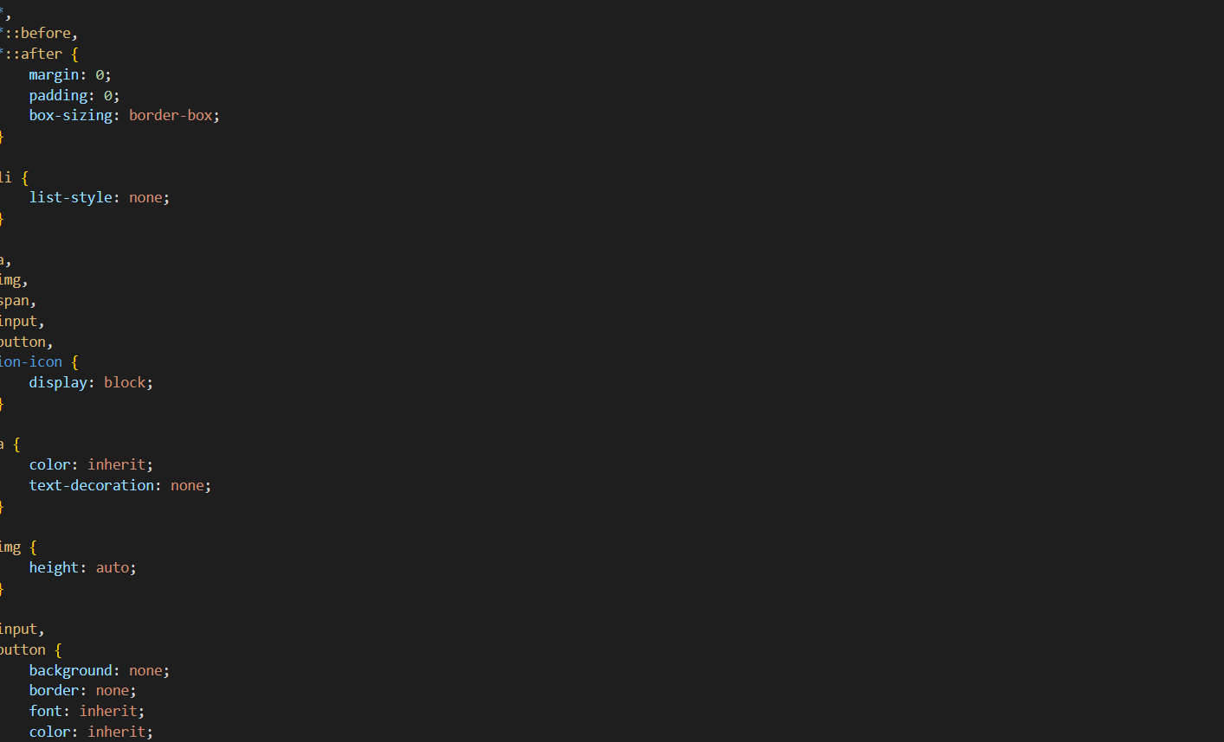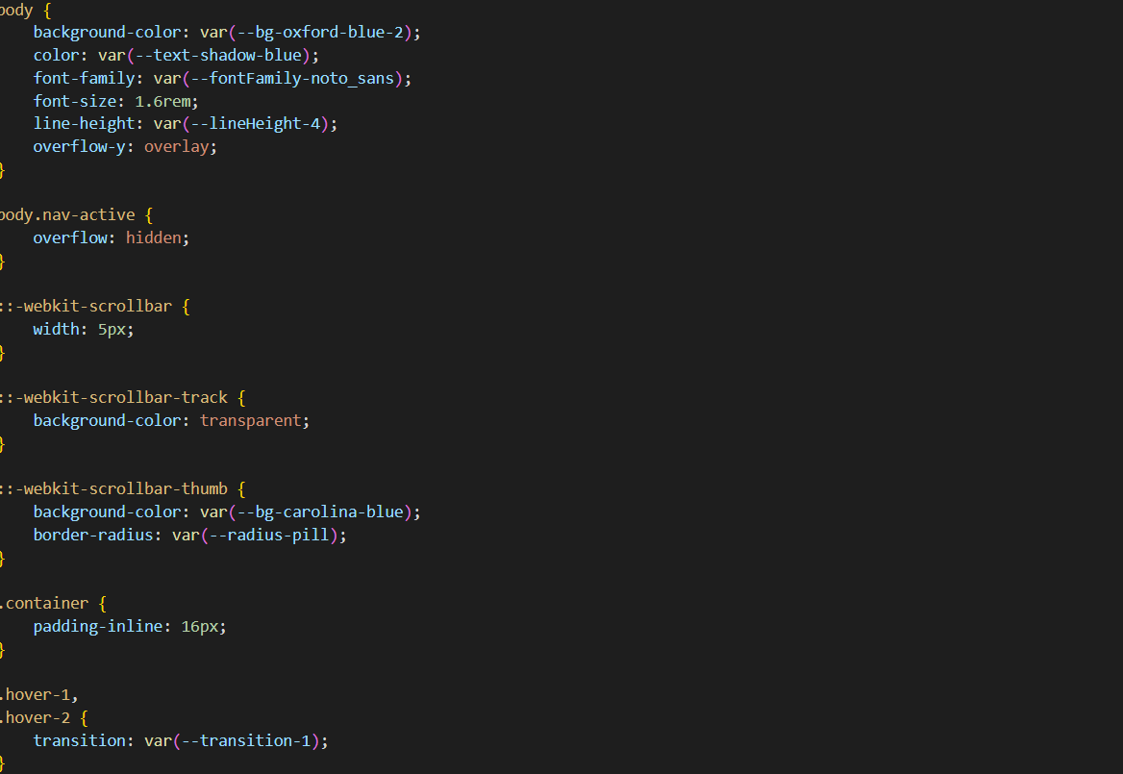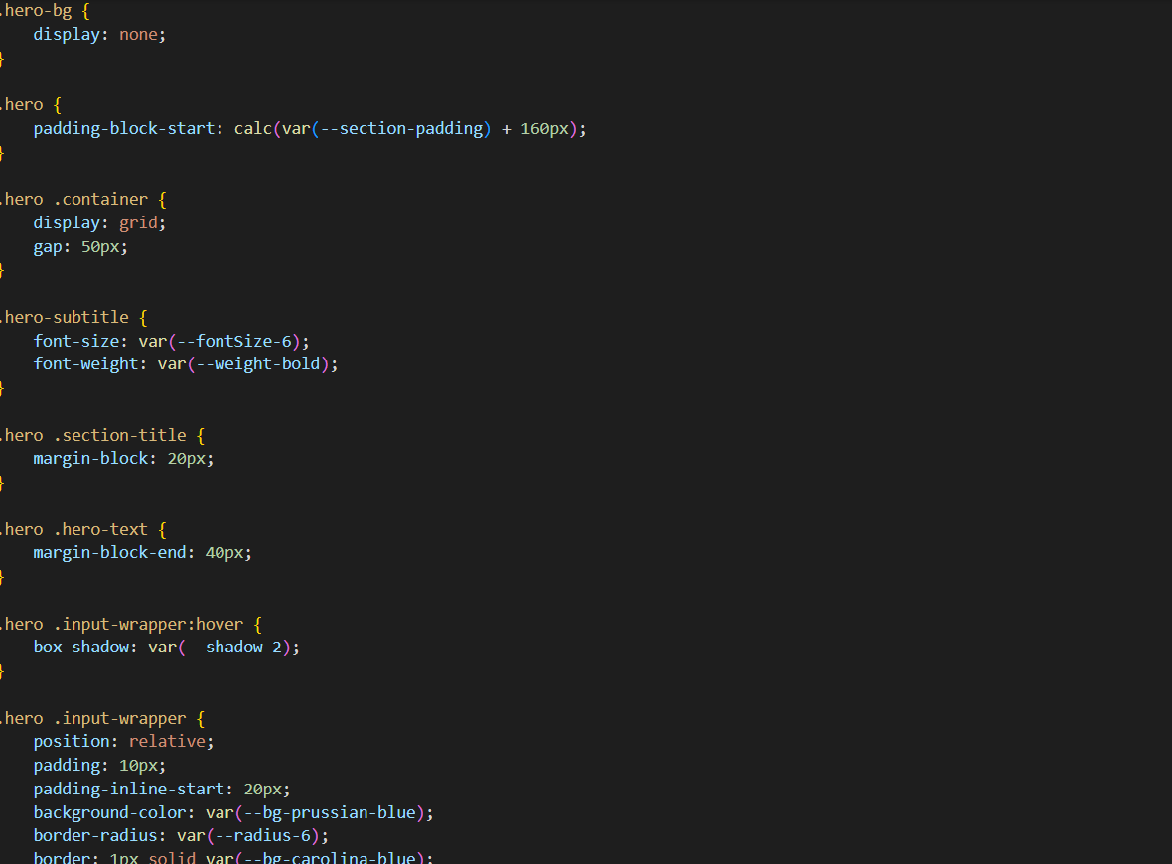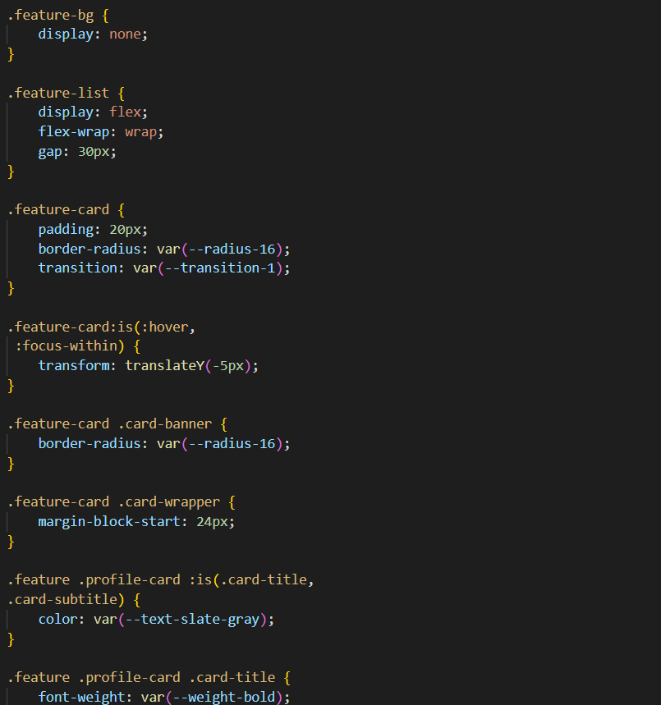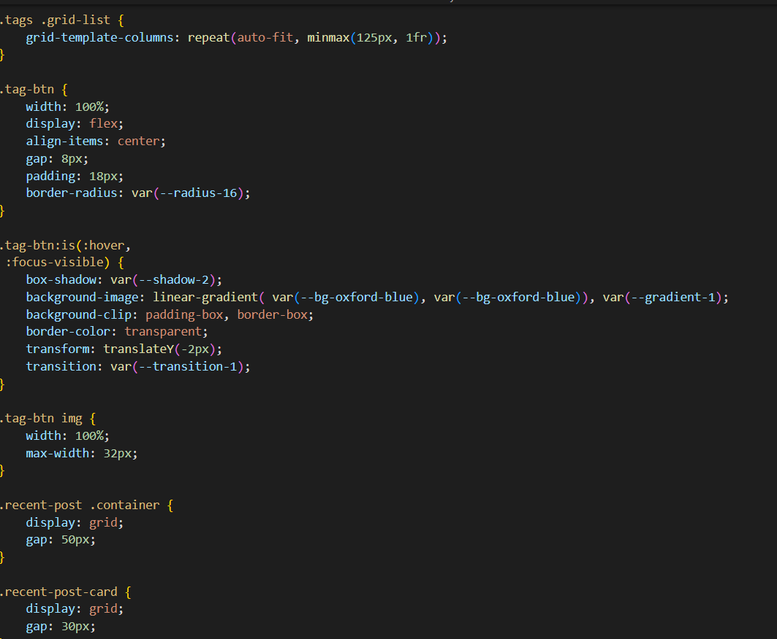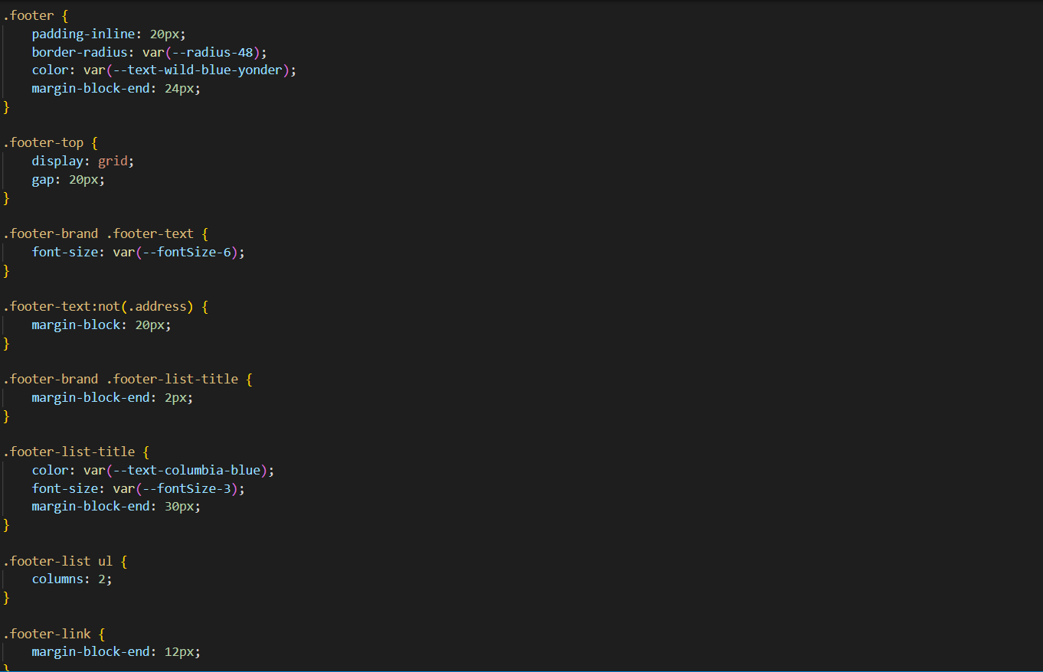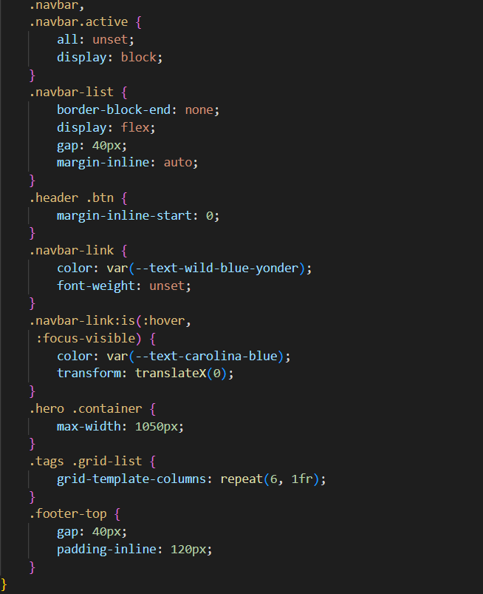

OUTPUT

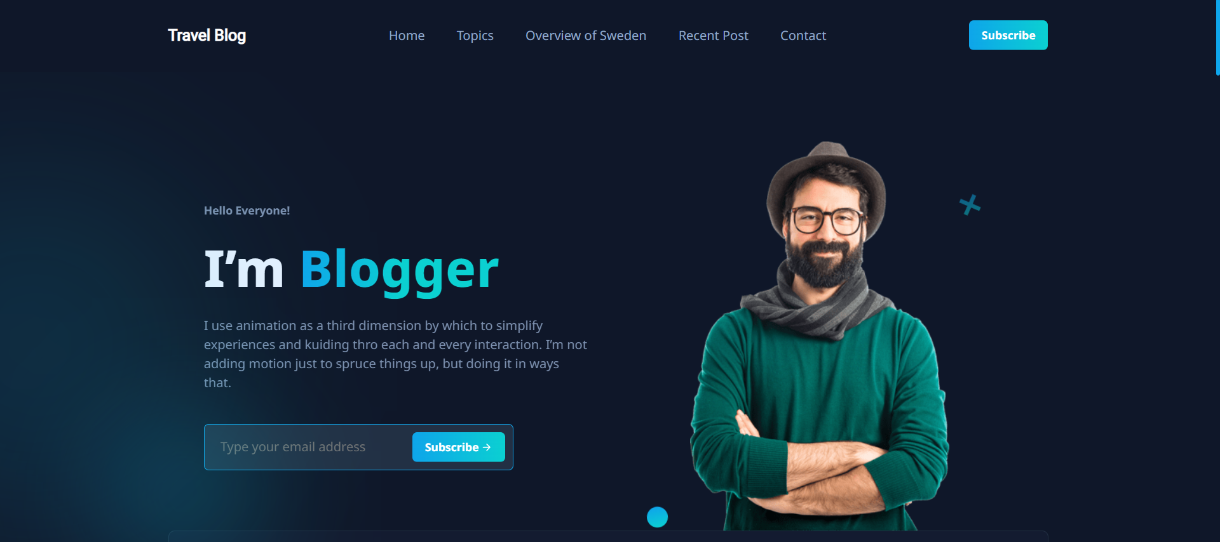

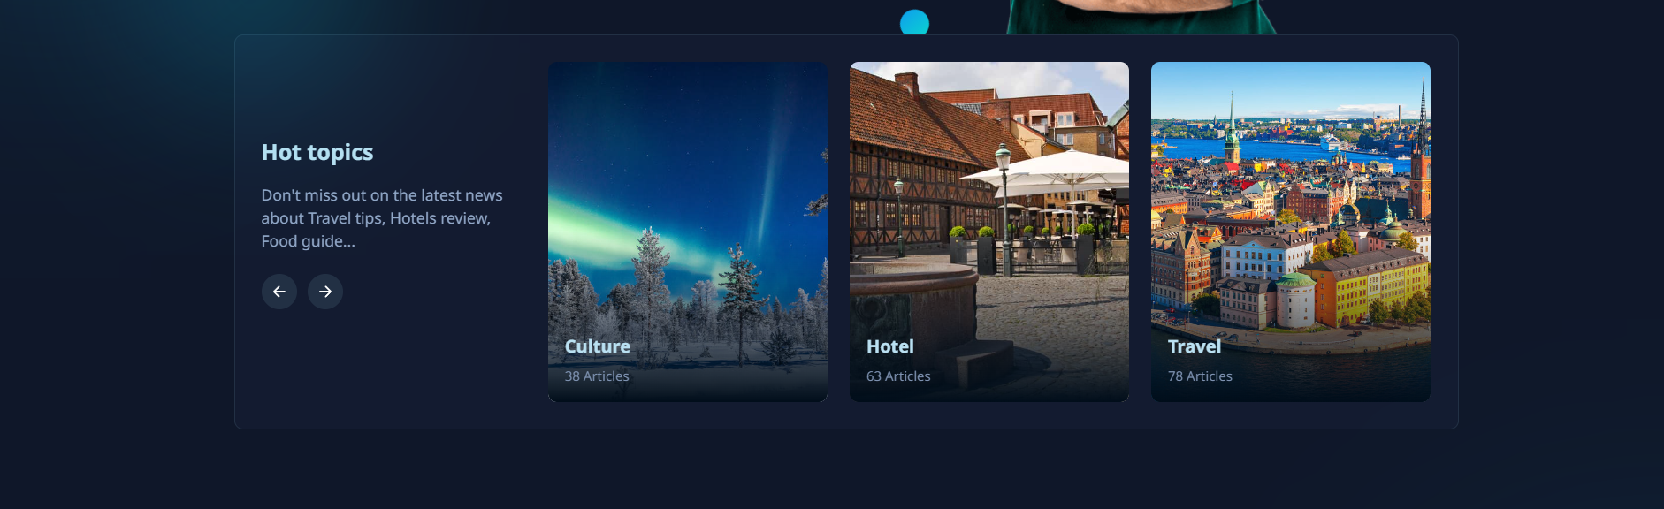

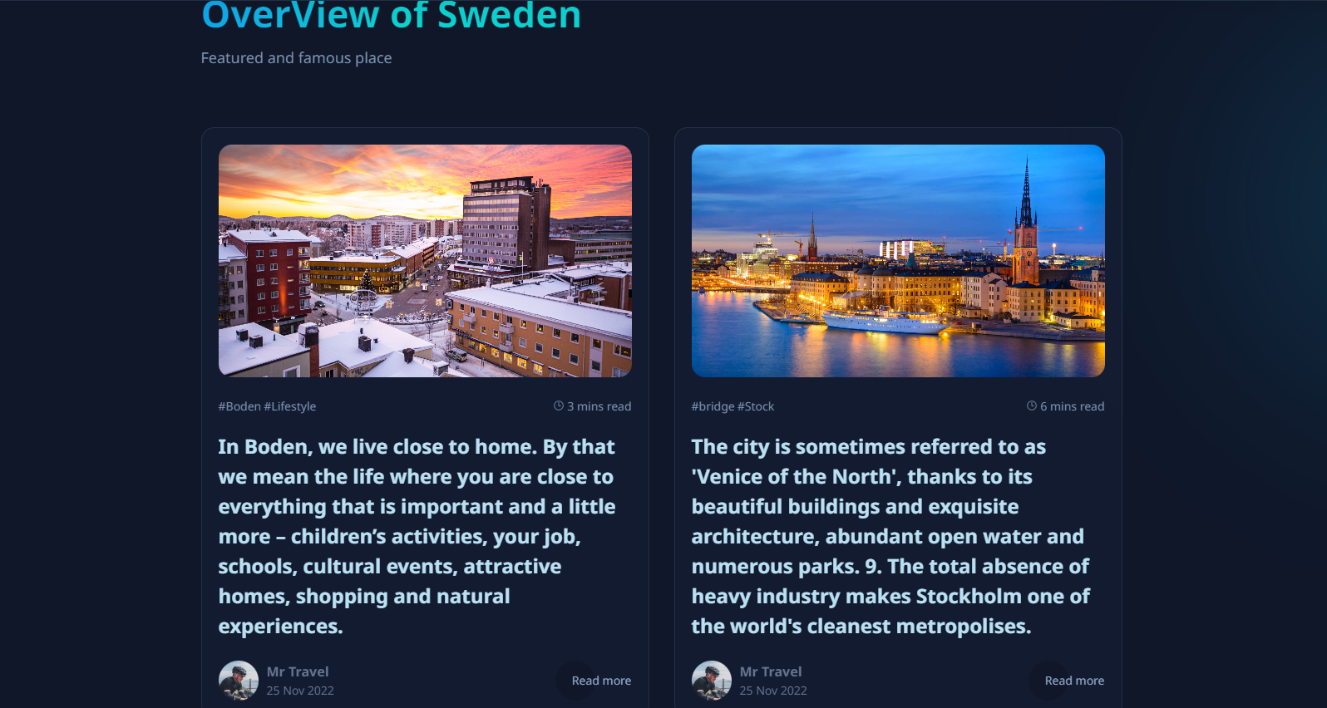

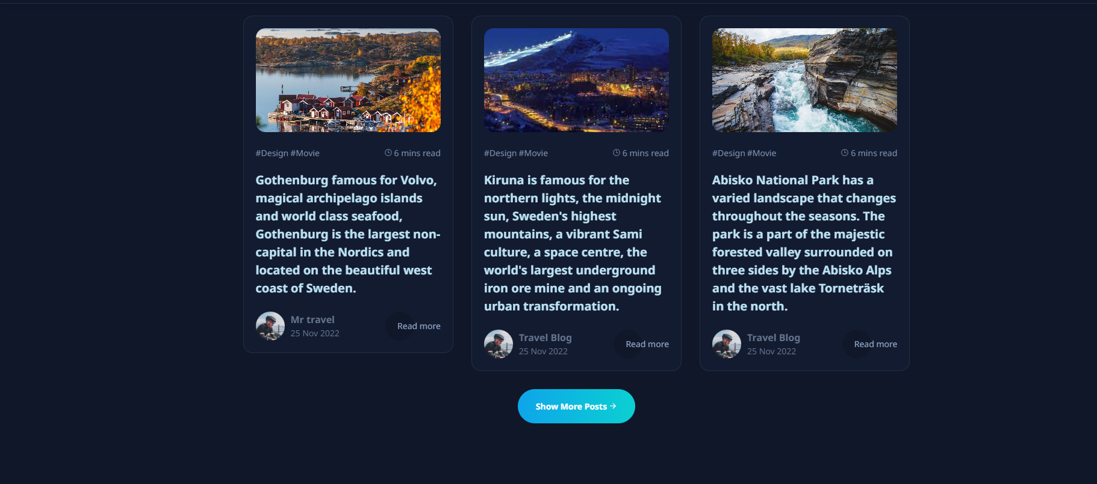

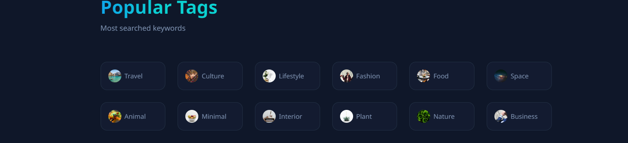

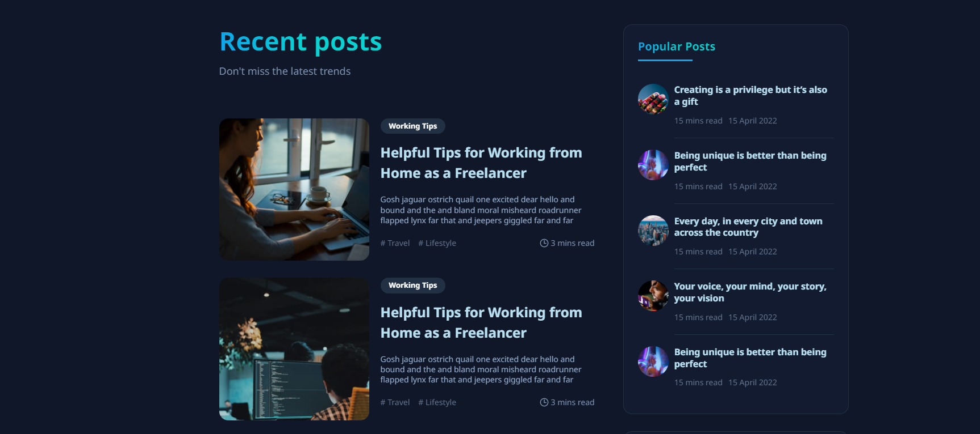

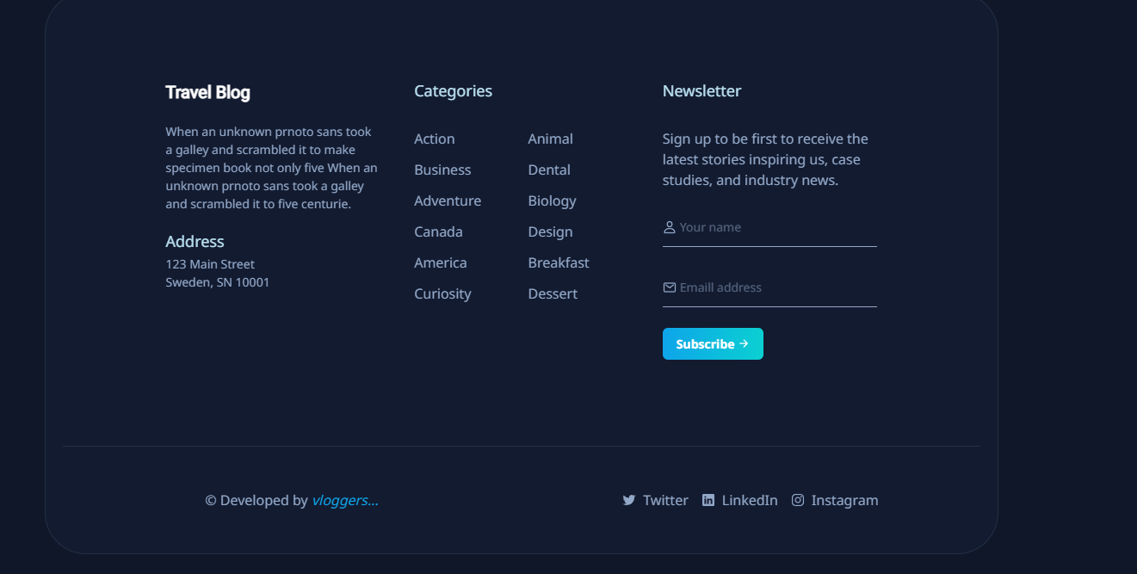

**CONCLUSION**

The statement outlines the creation of a personal travel blog, "Roaming Clouds," with a focus on leveraging the latest cloud-based static web app technology to offer a dynamic travel experience. The project entails a thorough process, starting with the requirement gathering phase that emphasizes understanding the website's purpose, collecting travel-related content, and listing desired features, along with competitor research. In the planning stage, the chosen technology stack of HTML and CSS is identified, the website structure is planned, IBM Cloud Static Web Apps is selected as the hosting provider, and travel media resources are gathered. The statement also mentions the inclusion of a navigation bar for user convenience. The development phase is initiated with the creation of a basic website structure using HTML and CSS. Overall, the project's goal is to inspire and engage users with travel adventures and tips, facilitated by the power of cloud technology.